Lab G – Cloud Attack

Timothy Victori

Arizona State University

IFT 202

Gary Grindle

9/22/2024

Screenshot 1
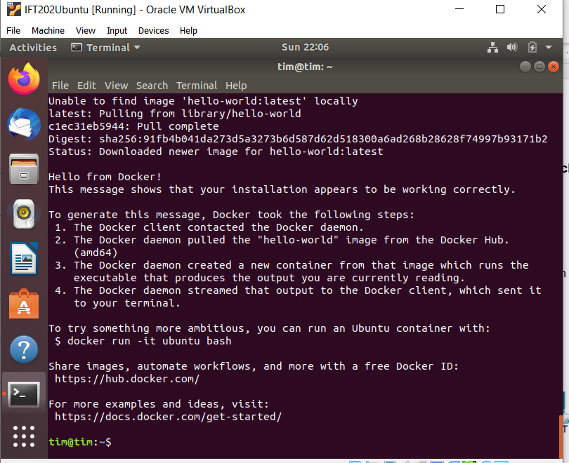
Screenshot 2
